TRI-COUNTY RURAL WATER DIST. #2
Pottawatomie County, Oklahoma

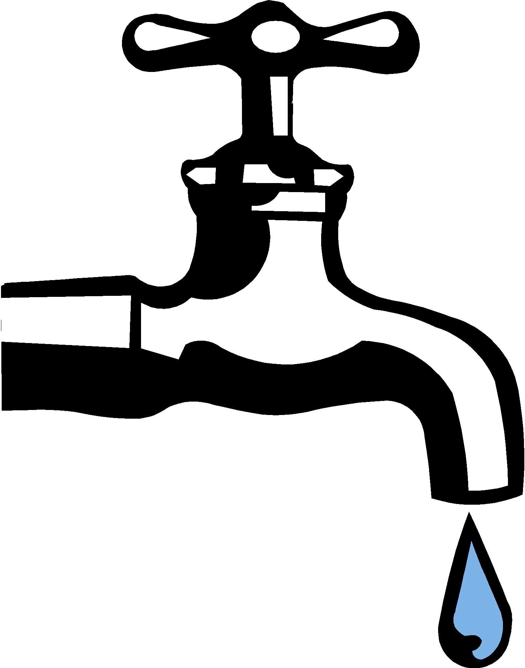

TERMINATION OF MEMBERSHIP

I, _____________________________________, ACCOUNT #____________________,
Wish to TERMINATE my membership.

_______________________________________________________________
PROPERTY ADDRESS

I understand that to have service reconnected will be a NEW MEMBERSHIP Fee.

Current New Residential Membership Fee is $2,500.00
Current New Commercial Membership Fee is $4,000.00

__________________________________________________
P.O. Box 118 · Earlsboro, Oklahoma 74840-0118 · (405) 997-5390 · Fax (405) 997-5457
www.tricountyrwd2.myruralwater.com
Tri-County RWD #2 is an equal opportunity employer and provider.
Hearing Impaired Contact Number: 800-722-0353

SIGNATURE

_____________________________
DATE

